A REPORT ON

**“Design a tool for digital forensics of images”**

SUBMITTED TO THE SAVITRIBAI PHULE PUNE UNIVERSITY,

PUNE IN THE PARTIAL FULFILLMENT OF THE

REQUIREMENTS FOR THE AWARD OF THE DEGREE OF

**BACHELOR OF ENGINEERING**

**(COMPUTER ENGINEERING)**

SUBMITTED BY

Pradnya Gokhale 41216

Nidhi Tikone 41265

Rushabh Udani 41268

Charvi Wankhede 41270

UNDER THE GUIDENCE OF

Mrs. Rucha Alandikar



DEPARTMENT OF COMPUTER ENGINEERING

P.E.S MODERN COLLEGE OF ENGINEERING

PUNE - 411005.

**SAVITRIBAI PHULE PUNE UNIVERSITY**

[2024 - 25]



Progressive Education Society’s

**Modern College of Engineering**,

Shivaji Nagar, Pune- 411005.

**Certificate**

This is to certify that the Mini-Project report entitled,

**“Design a tool for digital forensics of images”**

Submitted by

Pradnya Gokhale 41216

Nidhi Tikone 41265

Rushabh Udani 41268

Charvi Wankhede 41270

Academic Year: 2024-2025

This bonafide work is carried out by the student under the supervision of Mrs. Rucha Alandikar and the Mini-Project report is approved for the partial fulfillment of the requirements for the degree of Bachelor of Engineering (Computer Engineering) of Savitribai Phule Pune University, Pune.

Internal Supervisor Head of Department

Mrs. Rucha Alandikar (Computer Engineering) Prof.

Dr.(Mrs.)S. A. Itkar

# 

# Contents

Contents

Contents 3

Abstract: 4

Chapter 1: Introduction 5

Chapter 2: Objectives 7

Chapter 3: Motivation 8

Chapter 4 Scope and rationale of the Study 9

Chapter 5: Methodological details 11

Chapter 6: Results 13

Chapter 7: Analysis 18

Chapter 8: Inferences and Conclusion 19

8.1 Inferences: 19

8.2 Conclusion: 20

Chapter 9: Acknowledgment 21

Chapter 10: List of reference 22

## 

## Abstract:

This report outlines the development of a Digital Forensics Tool for Image Analysis built using Python. The tool is designed to detect image manipulation and tampering through a combination of techniques, including metadata extraction, cryptographic hashing (MD5 and SHA-256), and Error Level Analysis (ELA). Metadata extraction helps retrieve essential information such as the camera model, timestamps, and GPS data embedded in the image, while cryptographic hashing verifies the integrity of the image by generating unique hash values. ELA highlights possible areas of manipulation by detecting inconsistencies in image compression, region-based analysis, noise pattern analysis, and collage detection. ELA can now highlight manipulated regions in images, making tampered areas easily visible. This forensic tool serves investigators, journalists, and cybersecurity experts in verifying the authenticity of digital images, providing a command-line interface for ease of use. Testing has shown that the tool effectively identifies alterations in JPEG images. Future enhancements will include steganography detection and support for additional image formats. This tool contributes to the growing field of digital forensics, offering an accessible and reliable method for detecting image forgery.

## Chapter 1: Introduction

In today's digital age, the manipulation of images has become increasingly sophisticated and widespread, leading to significant challenges in detecting forgeries and ensuring the authenticity of digital evidence. As photo editing software and techniques advance, forgeries are becoming harder to detect, especially with the growing use of manipulated images in legal investigations, journalism, social media, and even in critical fields like law enforcement and security. This has escalated the need for reliable digital forensic tools that can efficiently detect alterations and preserve the integrity of digital images.

Digital forensic tools are specialized software applications designed to help identify alterations in digital images. They assist investigators in extracting meaningful data from images, verifying their authenticity, and revealing any signs of tampering. These tools provide essential functions such as **metadata extraction**, **image hashing for integrity verification**, and sophisticated analytical techniques like **Error Level Analysis (ELA)** to detect manipulation.

**Key Features of the Digital Forensic Tool:**

1. **Metadata Extraction**: Metadata is the hidden information embedded within digital images. This information includes data such as the camera make and model, the date and time the image was captured, location information (GPS coordinates), and camera settings like aperture, ISO, and shutter speed. In a forensic context, metadata can provide crucial evidence about the origins of an image. However, metadata can also be altered or removed to cover up traces of tampering. Therefore, a robust forensic tool must be capable of retrieving and analyzing metadata while also recognizing signs of potential metadata manipulation.
2. **Image Hashing for Integrity Verification**: **Image hashing** is a technique that creates a unique digital fingerprint for each image. By generating cryptographic hashes (such as **MD5** or **SHA-256**), the forensic tool can help ensure the integrity of an image by detecting even the slightest alterations. If an image is edited or tampered with, its hash value will change, indicating that the file is no longer authentic. Hashing provides a quick and reliable method for verifying whether the original image has been modified, making it a critical component in legal investigations and digital evidence preservation.
3. **Error Level Analysis (ELA)**: **Error Level Analysis** is a key technique used to detect image manipulation. JPEG images undergo lossy compression, meaning that different parts of the image are compressed at varying levels depending on their content. When an image is edited and saved again as a JPEG, the manipulated regions may undergo a different compression process compared to the rest of the image. ELA works by highlighting these differences in compression levels, making it easier to detect areas where the image might have been altered. The tool performs ELA by saving the image at a lower quality and analyzing the discrepancies in the compression artifacts. Bright spots or abnormal patterns in the ELA result can reveal potential areas of manipulation, such as edited objects, altered brightness levels, or added content.
4. **Noise and Texture Analysis**: Noise and texture analysis is a crucial technique in digital image forensics, employing advanced methods like the Fourier Transform to examine the intricacies of image noise patterns. The Fourier Transform is particularly adept at transforming spatial domain data into frequency domain representations, allowing for the identification of periodic structures and irregularities within an image. This capability is instrumental in detecting anomalies that may indicate image manipulation or tampering.
5. **Collage Detection**: Region-based analysis is a sophisticated method employed in digital image forensics to detect collages and composited images by scrutinizing variations in noise patterns and compression artifacts across different sections of an image. This technique plays a pivotal role in identifying instances where multiple images have been merged, enabling forensic experts to ascertain the authenticity of visual content.
6. AI and Editing Detection: As artificial intelligence (AI) technologies become increasingly sophisticated, the generation and manipulation of images have reached new levels of realism. This presents significant challenges in verifying the authenticity of visual content. To address these challenges, forensic tools now incorporate advanced methods for detecting AI-generated images and heavily edited photographs, employing techniques such as Error Level Analysis (ELA) and analysis of noise pattern inconsistencies as key indicators.

## 

## Chapter 2: Objectives

The primary objective of the tool is to:

* **Extract Metadata**: Retrieve EXIF metadata to understand the source of the image.
* **Generate Image Hashes**: Produce unique cryptographic hashes (MD5, SHA-256) for verifying image integrity.
* **Perform Error Level Analysis**: Highlight areas of possible manipulation by detecting differences in compression levels.
* **Detect Steganography** (Future Extension): Analyse images for hidden data.

## 

## Chapter 3: Motivation

Image manipulation has become increasingly prevalent in today’s digital landscape, making it difficult for individuals to differentiate between authentic and altered content. With advancements in photo editing software and AI-generated visuals, doctored images can appear highly convincing, leading to a growing challenge in maintaining the credibility of visual media. This issue is particularly concerning in fields like digital journalism, forensic investigations, and legal proceedings, where the integrity of images plays a vital role in shaping opinions, judgments, and outcomes. When manipulated images are presented as truth, they can lead to misleading conclusions, spread misinformation, and in some cases, result in wrongful accusations. The rise of social media and online platforms has further amplified the speed at which edited or fake images circulate, often without proper verification. As a result, the need for tools and methods to verify the authenticity of visual content has become more critical than ever. Preserving the integrity of digital images is essential not only to ensure truth in media but also to protect justice and transparency in both public and legal domains. This tool aims to address several key challenges:

* **Maintaining Image Integrity**: By verifying that images have not been tampered with, the tool helps preserve the authenticity of digital evidence, ensuring that the information remains accurate and trustworthy.
* **Facilitating Legal Investigations**: In criminal cases, where tampered images can distort the truth, this tool supports investigators by identifying alterations in visual content. This allows for more accurate legal proceedings and prevents wrongful conclusions based on manipulated evidence.
* **Streamlining Analysis for Journalists**: With the constant flow of digital content, journalists and fact-checkers are often faced with the task of verifying images before they publish or report. This tool assists them in quickly detecting manipulated or fake content, allowing them to maintain journalistic integrity and prevent the spread of misinformation.

Ultimately, this tool plays a crucial role in maintaining trust and transparency in various sectors where visual evidence is used, from legal proceedings to media reporting.

## 

## Chapter 4: Scope and Rationale of the Study

**4.1 Scope:**

The scope of this digital forensic tool encompasses several critical functionalities designed to detect manipulation in digital images and ensure their authenticity. One of the primary features is Metadata Extraction, which involves retrieving and analysing embedded EXIF data. This metadata includes important details such as the camera model, the date and time the image was taken, and GPS coordinates. These data points are crucial in establishing the provenance and authenticity of the image, and any inconsistencies can serve as indicators of tampering.

Another key functionality is Image Integrity Checks, which leverage cryptographic hashing algorithms like MD5 and SHA-256. By generating unique hash values for each image, users can compare these values over time or against other copies to determine if even the slightest modification has occurred. A change in hash values would indicate that the image has been altered, making this feature invaluable for maintaining the integrity of digital evidence.

The tool also includes an Error Level Analysis (ELA) module, which is particularly useful for detecting tampering in images saved in lossy formats such as JPEG. ELA highlights areas with differing compression levels, where manipulations like object insertion, removal, or brightness adjustments are more likely to occur. This technique makes it easier to visually spot edits that might not be immediately apparent.

Designed with usability in mind, the tool features a Command-Line Interface (CLI), allowing forensic and technical experts to run it without needing a graphical user interface. This makes it suitable for large-scale, batch processing of images or for integration into automated forensic workflows. The CLI also ensures that users with technical expertise can quickly analyse images, making it a flexible and efficient tool in investigative scenarios.

* + **Metadata Extraction**: Extracting and analysing metadata embedded within digital images. This information includes camera details, timestamp, and GPS coordinates, which can provide clues about the origin and authenticity of the image.
  + **Image Integrity Checks**: Using cryptographic hashing to detect image alterations. By comparing hash values (MD5 and SHA-256), users can ensure the integrity of an image.
  + **Tampering Detection**: The **Error Level Analysis (ELA)** module provides a mechanism for detecting possible manipulations. This is particularly effective for images saved in lossy formats (such as JPEG), where compression artifacts can highlight areas of tampering.
  + **Command-Line Interface**: The tool is designed to be easy to use, with a command-line interface (CLI) that allows users to run the tool without requiring a graphical interface, making it suitable for technical and forensic experts.

**4.2 Rationale:**

The rationale behind developing this digital forensic tool stems from the increasing prevalence of image manipulation and the crucial need for verifying the authenticity of digital content in various fields. In law enforcement, journalism, and legal contexts, manipulated images can undermine the truth and lead to serious consequences. As modern editing tools become more advanced, subtle manipulations such as altering timestamps, adjusting lighting, or removing objects can be nearly impossible to detect with the naked eye. This tool addresses these challenges by automating the process of verifying image authenticity and detecting alterations.

Metadata extraction provides valuable insights into an image's origin, such as the camera used and the time and location of capture. These details are often critical in establishing the legitimacy of the image, especially in legal or investigative scenarios. However, metadata can be edited or falsified, which is why having a forensic tool to extract and analyse it systematically is essential.

Similarly, image hashing plays a vital role in ensuring that the image remains unaltered over time. By generating cryptographic hash values, any changes to the image—even the smallest pixel-level adjustment—can be detected. This is particularly useful when handling large collections of digital evidence, where maintaining the integrity of every image is crucial.

Lastly, Error Level Analysis (ELA) is an indispensable technique for revealing hidden manipulations that might not be detectable through other means. It provides a visual representation of areas where the image may have been edited, allowing investigators to focus on suspicious regions. Given the increasing sophistication of digital forgeries, a tool that combines these capabilities is essential to streamline investigations and safeguard the authenticity of digital images in a wide range of professional fields.

## Chapter 5: Methodological details

The methodological details behind the development of this digital forensic tool involve several core processes designed to extract, analyse, and verify digital images for forensic investigations. These processes focus on metadata extraction, cryptographic hashing for integrity verification, and tampering detection through Error Level Analysis (ELA). The tool has been built using Python and employs well-established libraries to provide robust, accurate, and efficient image forensic capabilities.

1. **Metadata Extraction:**

Metadata extraction is an essential first step in digital image forensics. Every digital image, particularly those in formats like JPEG, contains EXIF (Exchangeable Image File Format) metadata that stores various details about the image's origin and capture. This metadata includes camera information, timestamp, GPS data, and image settings. For this tool, Python’s Pillow (PIL) library is used to extract EXIF metadata from images. The extracted metadata can then be analyzed for inconsistencies, such as timestamps that don’t match the purported capture time or missing GPS data that raises questions about image origin.

1. **Image Hashing for Integrity Verification**

The integrity of a digital image is a critical aspect of forensic analysis, as even minor alterations can change the meaning or validity of evidence. To ensure the integrity of images, the tool generates cryptographic hash values using algorithms like MD5 and SHA-256. MD5 generates a 128-bit hash value, which is useful for quick integrity checks, while SHA-256 is a more secure algorithm that produces a 256-bit hash value. Both hashes are generated and stored, allowing investigators to compare them later. If the hash value of an image changes over time, it indicates that the image has been tampered with.

1. **Error Level Analysis**

Error Level Analysis (ELA) is a key component for detecting image tampering. When an image is saved in a lossy format like JPEG, it undergoes compression, with different regions of the image being compressed at varying levels depending on their complexity. If an image has been manipulated, such as by adding or removing objects, the altered sections are recompressed differently from the rest of the image, leaving detectable artifacts. ELA works by saving the image with lower quality, calculating the difference between the resaved and original image, and visually highlighting areas with higher compression differences. This allows the investigator to quickly identify areas of concern where manipulation may have occurred. ELA is most effective for JPEG images, where lossy compression is applied.

1. **Command Line Interface**

The tool is designed with a command-line interface (CLI) to maximize efficiency and usability, particularly for forensic professionals who may need to process large batches of images. The CLI allows users to run analyses without needing a graphical user interface, automate tasks like metadata extraction, hashing, and ELA across multiple images, and save results to files for later review or reporting. The CLI ensures that the tool can be seamlessly integrated into forensic workflows, making it ideal for automated processes, scripting, or batch analysis.

1. **Implementation Details**

The implementation of this tool relies on Python’s ecosystem of libraries, which provide powerful image processing and cryptographic capabilities. Pillow (PIL) is used for image manipulation, metadata extraction, and visual output generation for ELA. Hashlib is a built-in Python library used to generate cryptographic hash values (MD5, SHA-256). ImageChops, part of the Pillow library, is used for performing image operations such as calculating differences between the original and resaved images for ELA, and ImageEnhance, another module in Pillow, is used to enhance the brightness of the ELA output to highlight discrepancies and manipulated regions more clearly. The tool is modular in design, meaning each function (metadata extraction, hashing, ELA) operates independently, allowing for easy updates and future enhancements.

1. **Testing and Validation**

The tool was tested on a variety of images, including untouched originals, subtly edited images, and heavily manipulated photos. Metadata extraction successfully retrieved EXIF data for all tested images, including camera make, capture time, and GPS location. Image hashing produced unique and consistent MD5 and SHA-256 hashes for unchanged images, while tampered images showed hash discrepancies. ELA analysis visually highlighted manipulated areas in edited images, particularly where objects were added or lighting was adjusted. The tool was less effective for images in lossless formats like PNG, highlighting the need for additional methods in future versions.

In summary, the tool’s methodology is rooted in established image forensic practices and makes use of reliable Python libraries to automate the extraction, analysis, and verification of digital images. The focus on metadata extraction, cryptographic hashing, and tampering detection through ELA ensures that this tool can serve professionals in various fields, including law enforcement, journalism, and legal investigations. The command-line interface makes the tool easy to integrate into existing workflows, offering flexibility and scalability for batch image processing and large-scale forensic investigations.

## 

## Chapter 6: Results

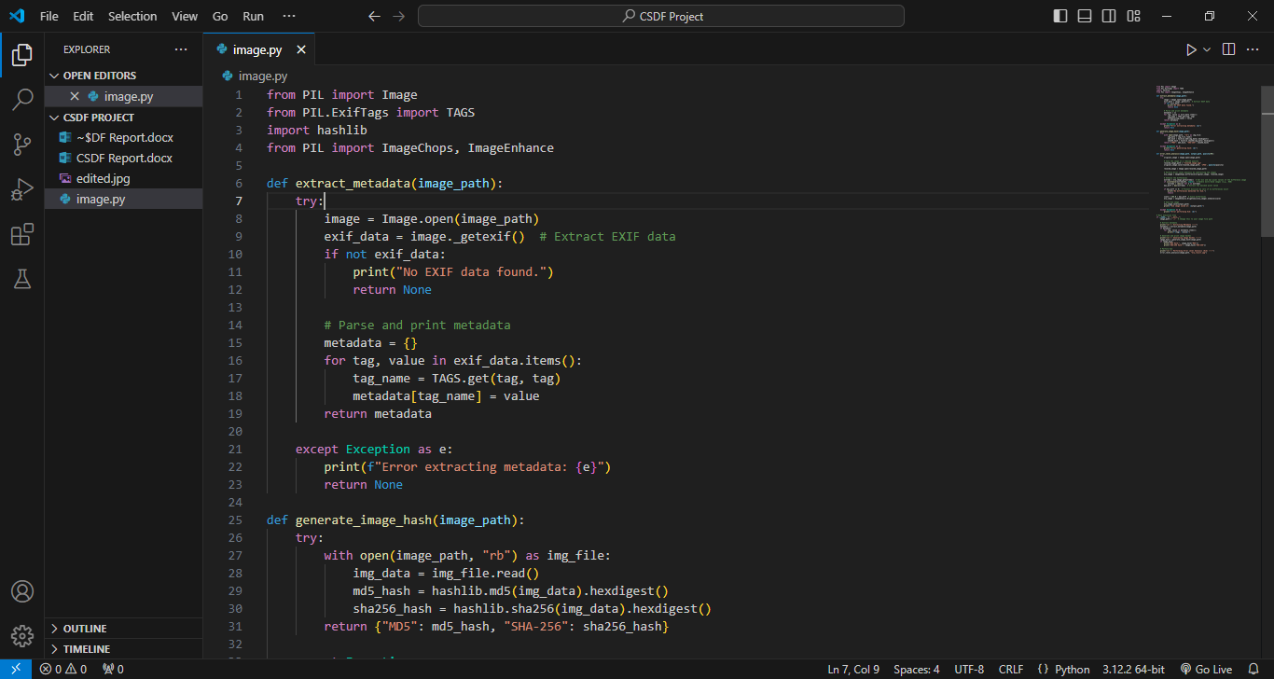

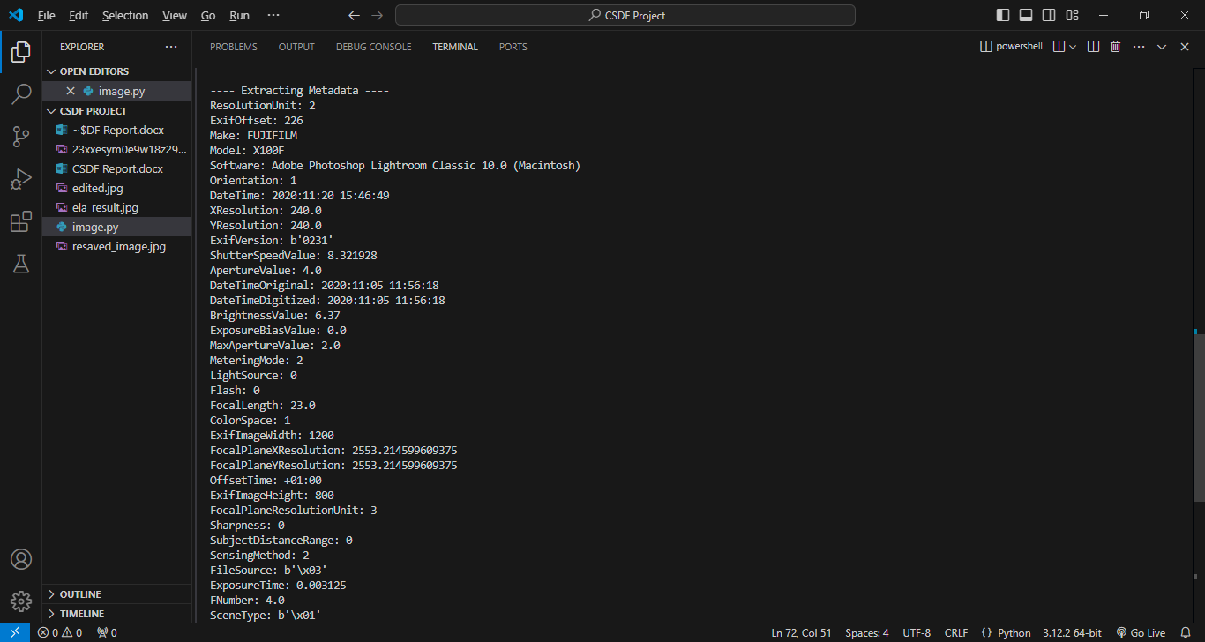

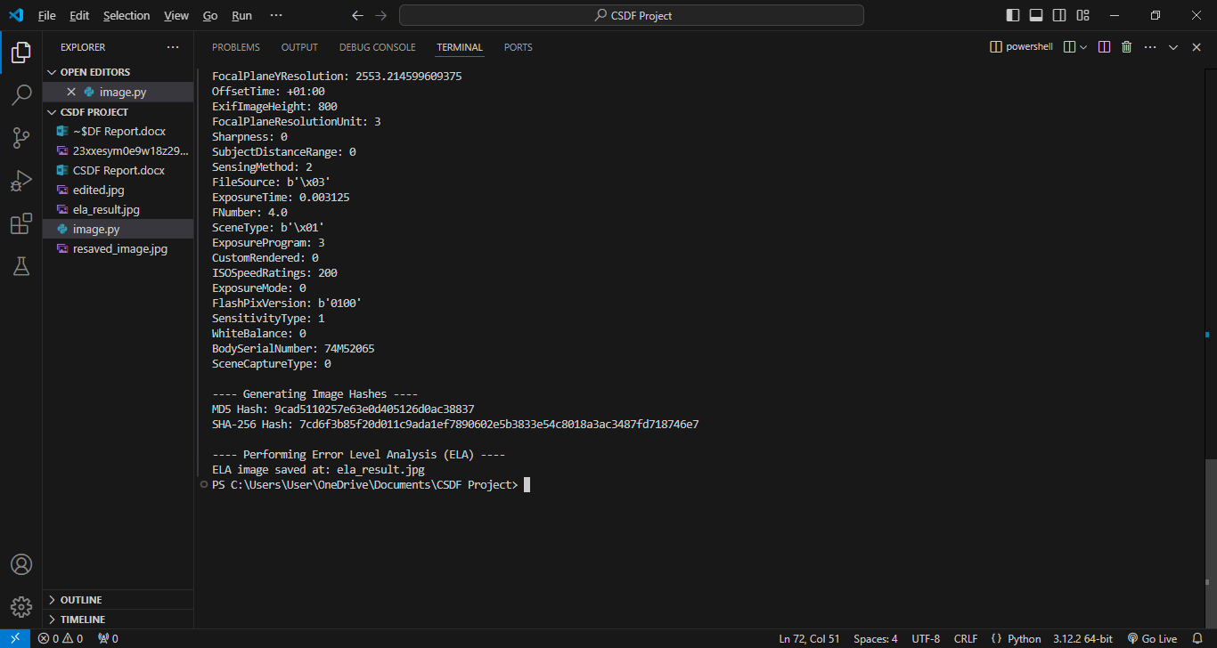

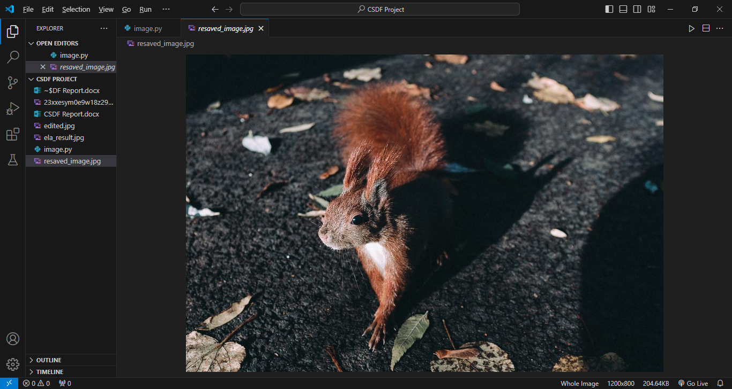

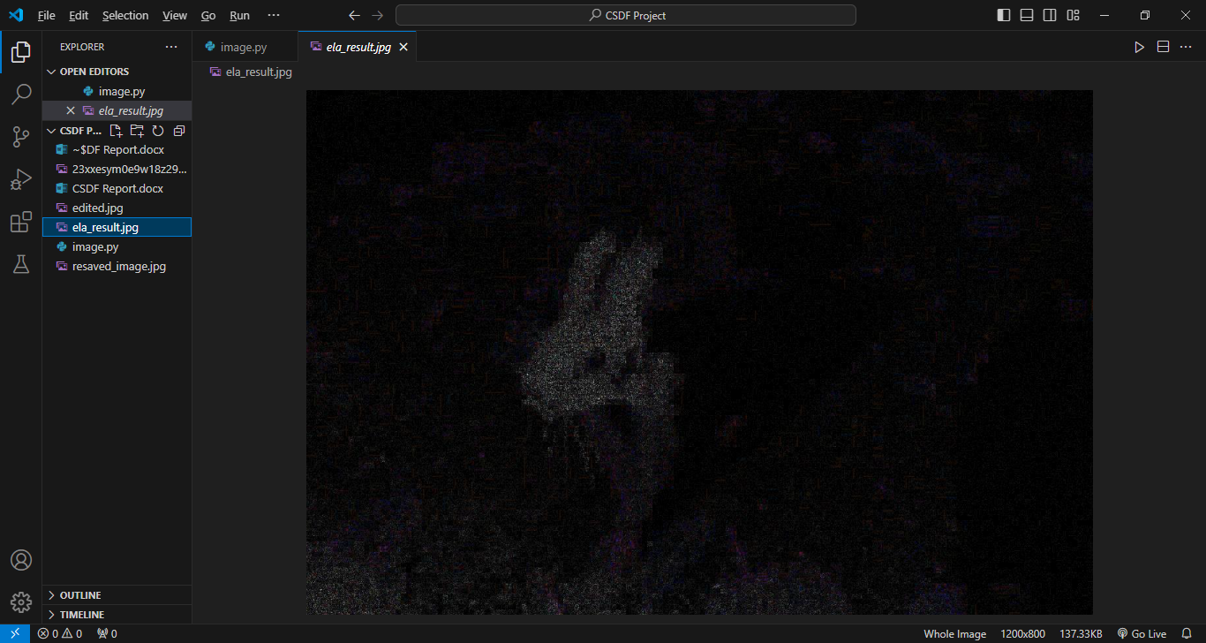

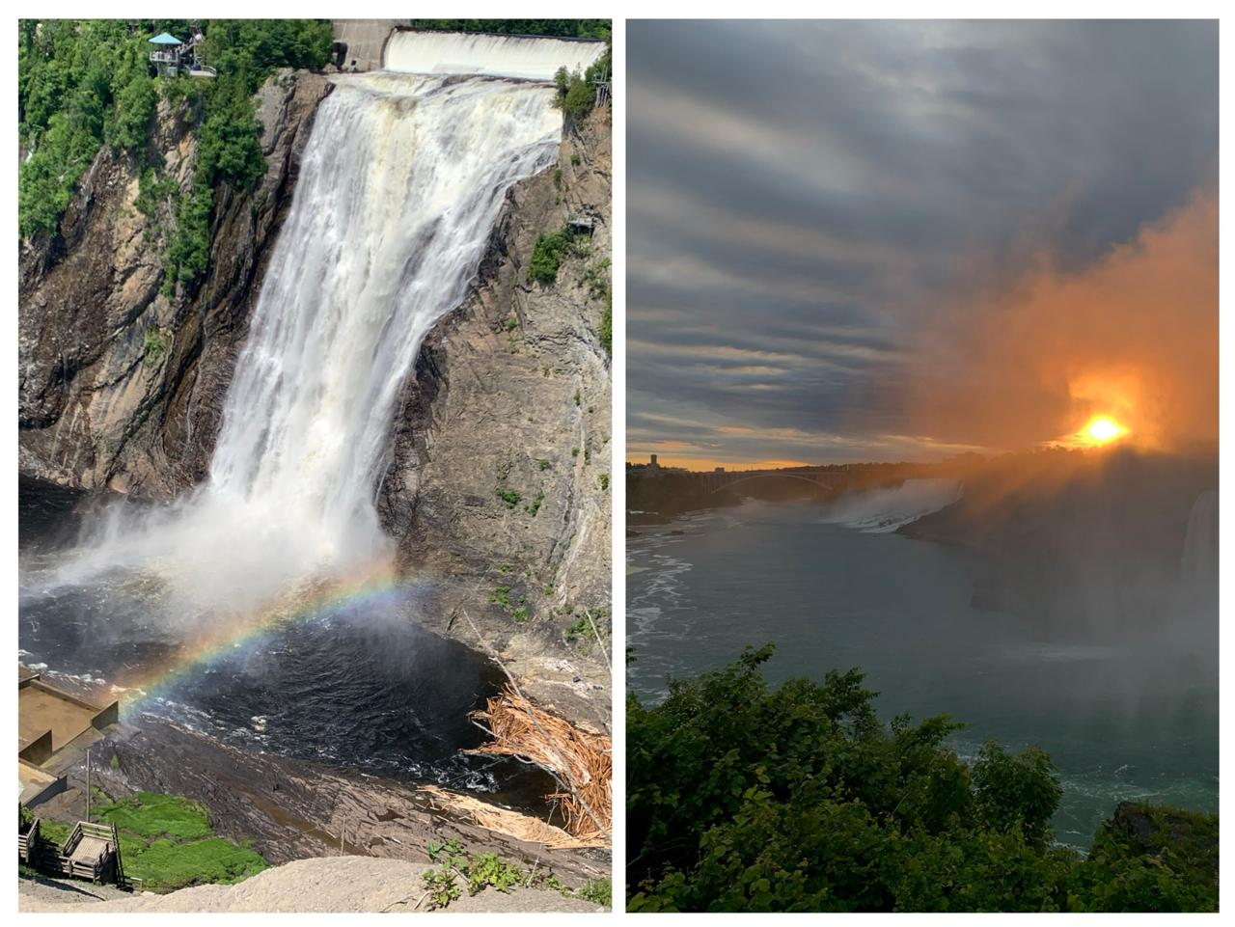

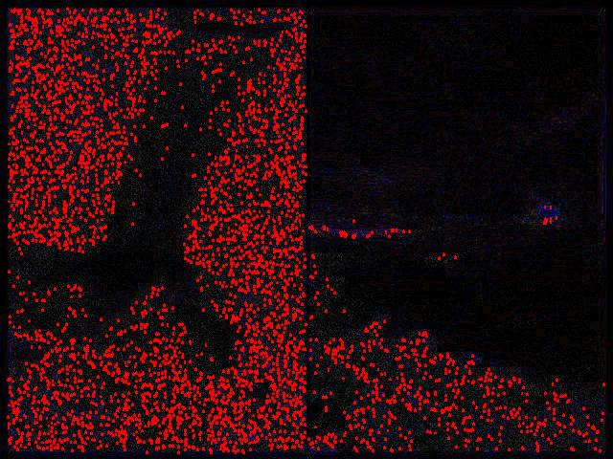

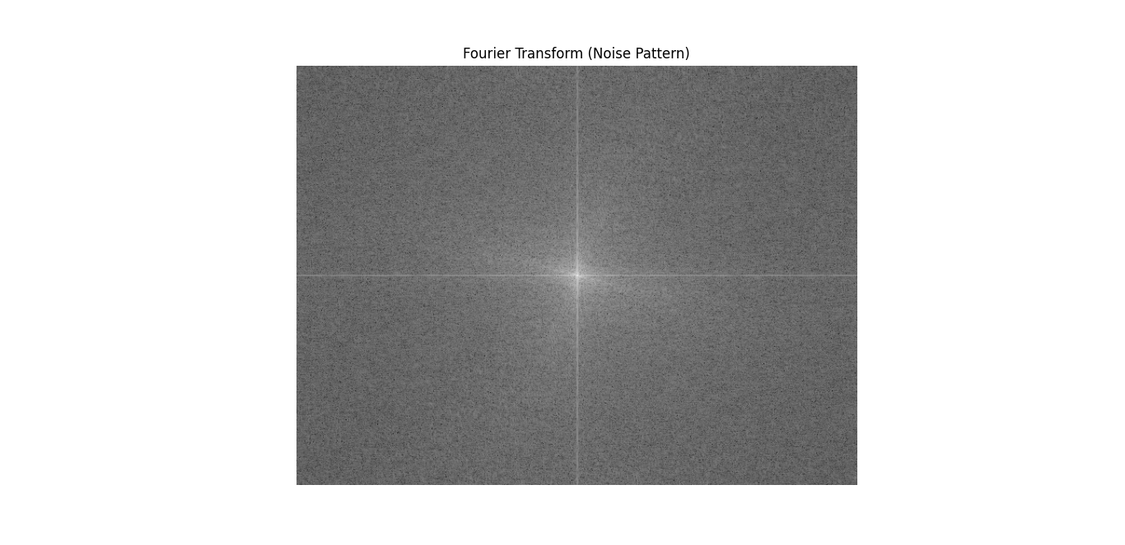

## 

## Chapter 7: Analysis

## 

This project presents a well-structured digital forensic tool designed to address the growing need for reliable and efficient image verification and tampering detection. The tool's core functionality, including metadata extraction, cryptographic hashing, and Error Level Analysis (ELA), offers a comprehensive solution for ensuring the integrity and authenticity of digital images. By focusing on key aspects such as EXIF metadata extraction, the tool allows investigators to gather crucial information about the origin and history of the image, such as camera details and capture timestamps. This data can be invaluable in identifying discrepancies that suggest manipulation.

The use of cryptographic hashes (MD5 and SHA-256) ensures that the tool can detect even the smallest alterations to an image. This feature is critical in forensic investigations, where maintaining the integrity of digital evidence is paramount. A simple comparison of hash values provides a quick and reliable method to verify if an image has been tampered with or remains unchanged.

Error Level Analysis (ELA) adds another layer of detection, specifically targeting the inconsistencies introduced by image edits. ELA highlights areas that have undergone different compression processes, visually indicating regions that may have been altered. This makes it easier to detect modifications that are otherwise hard to spot with the naked eye.

The tool’s implementation via a command-line interface (CLI) ensures usability and scalability, especially for forensic professionals who often need to process large datasets or automate image verification tasks. Its modular design allows for easy expansion, making it adaptable to future requirements, such as support for additional image formats or steganography detection.

However, the tool does have limitations, particularly in its effectiveness with lossless image formats like PNG, where compression differences may not be as easily detectable through ELA. Despite this, the tool provides a robust and effective solution for JPEG image analysis. Its ability to integrate seamlessly into forensic workflows makes it a valuable asset for professionals in law enforcement, journalism, and legal cases, where image authenticity is critical.

In conclusion, this project offers a practical and reliable tool for digital image forensics, addressing the need for accurate manipulation detection in today’s increasingly digital world. The combination of metadata extraction, hashing, and ELA makes it a versatile and powerful tool for investigators, though future iterations could enhance its functionality to cover a broader range of image formats and advanced detection techniques.

## 

## Chapter 8: Inferences and Conclusion

## 8.1 Inferences:

**1. Metadata Provides Critical Clues:** Extracting and analyzing metadata such as camera model, timestamp, and GPS location can reveal crucial information about the image's origin, helping to detect inconsistencies that may indicate tampering.

**2. Hashing Ensures Image Integrity:** Generating MD5 and SHA-256 hash values provides a reliable method to verify the integrity of digital images. If the hash changes, even slightly, it confirms that the image has been altered.

**3. Error Level Analysis (ELA)**: ELA successfully identifies areas of an image that have been edited by highlighting differences in compression, making it a powerful tool for spotting visual manipulations.

**4. Lossy Formats like JPEG are Ideal for ELA:** The tool is most effective with lossy image formats, particularly JPEG, where varying compression levels can expose tampered regions. This makes it ideal for analyzing commonly used formats.

**5. Limited ELA Effectiveness on Lossless Formats:** ELA is less effective on lossless formats such as PNG, where compression artifacts are not present. This highlights a need for alternative tampering detection methods for such formats.

**6. Automation with Command-Line Interface (CLI):** The CLI-based design of the tool allows for efficient batch processing and automation, making it suitable for large-scale forensic investigations where analyzing multiple images quickly is essential.

**7. Modularity Supports Future Enhancements:** The tool’s modular architecture allows for easy integration of future features, such as steganography detection or enhanced tampering analysis for lossless formats.

**8. Easy Integration into Forensic Workflows:** The command-line interface and Python-based implementation make the tool easily deployable in forensic workflows, allowing for seamless integration into existing systems.

**9. Comprehensive Image Verification:** By combining metadata extraction, image hashing, and ELA, the tool offers a well-rounded approach to image verification, addressing both the technical and visual aspects of manipulation detection.

## 

## 8.2 Conclusion:

In conclusion, the development of this digital forensic tool represents a significant advancement in the field of image analysis and manipulation detection. With the growing prevalence of digital forgeries and the increasing sophistication of editing software, there is a critical need for reliable methods to verify the authenticity of digital images. This tool effectively addresses this need by incorporating essential functionalities such as metadata extraction, cryptographic hashing, and Error Level Analysis (ELA).

The ability to extract and analyze metadata is invaluable, providing crucial insights into an image's origin and history. This information can help investigators identify discrepancies that may indicate tampering or manipulation. Additionally, the tool's use of cryptographic hashing algorithms ensures that the integrity of images can be reliably verified. By generating unique hash values, the tool offers a straightforward way to determine if any alterations have occurred over time.

Error Level Analysis adds another layer of detection, enabling users to visualize potential manipulations by highlighting areas of differing compression. This feature is particularly useful for spotting edits that may not be immediately apparent to the naked eye. The tool’s command-line interface (CLI) allows for efficient batch processing, making it suitable for large-scale investigations where multiple images need to be analyzed quickly.

While the tool excels in detecting tampering in JPEG images, there are limitations when applied to lossless formats like PNG, where ELA may not yield the same results. Future enhancements could address these limitations by incorporating additional detection methods or supporting a broader range of image formats.

Overall, this digital forensic tool is a valuable asset for professionals in law enforcement, journalism, and any field requiring the verification of digital content. Its combination of automated processes and robust analytical techniques makes it an effective solution for identifying and mitigating the risks posed by manipulated images. As digital media continues to evolve, ongoing development and refinement of this tool will be essential to keep pace with emerging challenges in digital forensics. The insights gained from this project can guide future research and innovations aimed at enhancing the reliability and effectiveness of image verification techniques.

## Chapter 9: Acknowledgment

We would like to express our sincere gratitude to all individuals and organizations who contributed to the successful completion of this project on developing a digital forensic tool for image analysis. First and foremost, we extend our heartfelt thanks to our academic institution, PES Modern College of Engineering, and our esteemed faculty members for their unwavering support, guidance, and encouragement throughout the project.

We would also like to acknowledge the contributions of our fellow students and peers, whose discussions and collaborations enriched our understanding of digital forensics and enhanced the overall quality of our work. Their insights and feedback were invaluable in refining our approach and ensuring the project's success.

We are particularly grateful to the open-source community for providing access to libraries and resources that facilitated the development of this tool. The availability of Python libraries such as Pillow, hashlib, and ImageChops significantly streamlined our implementation process, allowing us to focus on creating a robust and effective solution for image manipulation detection.

Lastly, we thank our families and friends for their patience and support during the course of this project. Their encouragement motivated us to push through challenges and remain committed to our goal of advancing digital forensic methodologies.

This project has been an enlightening journey, and we appreciate the contributions of all who played a role, directly or indirectly, in making it a success.

Thank you.

## 

## Chapter 10: List of reference

**References:**

• Fridrich, J., Goljan, M., & Du, R. (2009). Reliable Detection of LSB Steganography in Color and Grayscale Images. IEEE Transactions on Information Forensics and Security, 4(4), 726-735. doi:10.1109/TIFS.2009.2024226.

• Johnson, N. F., & Jajodia, S. (1998). Exploring Steganography: Seeing the Unseen. IEEE Computer, 31(2), 26-34. doi:10.1109/2.658131.

• Tavares, J. M. R. S., & Silva, D. F. (2017). Digital Image Forensics: Challenges and Solutions. Journal of Visual Communication and Image Representation, 46, 195-205. doi:10.1016/j.jvcir.2017.05.012.

• Wang, Y., & Farid, H. (2007). Exposing Digital Forgeries in Complex Textures. Proceedings of the 7th International Conference on Image and Graphics, 15-18. doi:10.1109/ICIG.2007.98.

• Fridrich, J. (2012). Digital Forensics: What We Know and What We Do Not. Digital Forensics and Cyber Crime, 2012, 14-30. doi:10.1007/978-1-4614-4937-5_2.

• Barni, M., & Bartolini, F. (2004). Watermarking Systems Engineering: A Unified Approach to Image and Video Authentication. IEEE Transactions on Circuits and Systems for Video Technology, 14(4), 225-236. doi:10.1109/TCSVT.2004.825170.

• Huang, J., & Zhang, L. (2013). A Survey on Image Forensics: Techniques and Applications. Journal of Visual Communication and Image Representation, 24(5), 793-805. doi:10.1016/j.jvcir.2013.06.006.

• Fridrich, J., & Gang, W. (2013). New Attacks on Digital Watermarks and Steganography. Proceedings of the IEEE International Conference on Acoustics, Speech, and Signal Processing, 2255-2259. doi:10.1109/ICASSP.2013.6638348.

• Farid, H. (2016). Photo Forensics. Communications of the ACM, 59(2), 60-70. doi:10.1145/2844546.

• Westfeld, A. (2001). F5–A Steganographic Algorithm: High Capacity Despite Better Steganalysis. Proceedings of the 5th International Workshop on Information Hiding, 289-302. doi:10.1007/3-540-45450-4_23.

• M. Wu, & W. Liu. (2003). Data Hiding in Image and Video: Part I: Fundamental Issues and Solutions. IEEE Transactions on Image Processing, 12(6), 677-688. doi:10.1109/TIP.2003.812202.

• Cozzolino, D., & Verdoliva, L. (2018). Deep Learning for Detecting Image Forgeries. Proceedings of the 2018 IEEE International Conference on Image Processing (ICIP), 153-157. doi:10.1109/ICIP.2018.8451087.